A G E N D A
- Meeting called to order (1min)  - Introductions: Name & “Favorite day of the year” (5min)  - Approve Minutes  - Network Scorecard Results and Insights (Cassandra-10min)  - Member Quality Meeting Insights and Next Steps (Dr. Karstens-30min)  - TCM Roadmap  - QI Training (Michelle)(5 min)  - RWHC Proposal  - Mayo  - Member Participation  - Wrap-up: (2min)  - Next meeting: July 12 from 7-8AM  - Action items:  - Adjourn |  | ACTION ITEMS for Next Meeting  Next Meeting Agenda  QI Training  Quality Metric Areas  - PHQ-9 Screening(Ambulatory and ED)  - Depression Follow-up and Remission  - TCM
M I N U T E S
Discussion | Conclusion
Meeting called to order and Introductions | Meeting called to order at 7:02 AM  Abby will plan to attend future meetings for CMH.
Approval of Meeting Minutes | Marilyn Denno made motion to approve minutes. Seconded by Beth Egan. Meeting minutes approved.
Network Scorecard Results and Insights | Wilderness Health Network Health Scorecard Survey reviewed at the Quality Improvement committee.  Full results are available per request.
Member Quality Meeting Insights and Next Steps | WH met with four members. Discussion focus on two areas (capacity and structures). WH moving towards network goals and planning to move towards a deeper dive for data extraction. WH plans to address contract measures and hospital focus measures like TCM (possibly working with FQHCs).  TCM overview process started at the UM committee. Reviewed the TCM network information with member. One big take away is a need for a pharmacist. Other item that trend from discussions was members are short staff and working with current resources.
QI Training | Mayo and Rural WI Health Corporative (two vendors selected for QI and leadership training).  Reviewed Mayo proposal in zoom meeting (quality academy).  Mayo offers several levels of training  -Bronze: Self-pace virtual module training (90 minutes course)  -Silver: Build upon bronze level content.  In person meeting might be challenging for department leaders to attend.  Kimber shared Northshore needs the foundational piece for department leads.  Mentimeter collected from members.  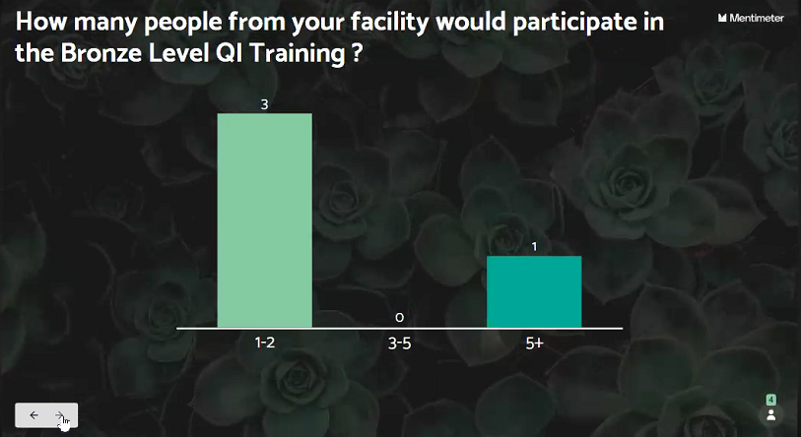  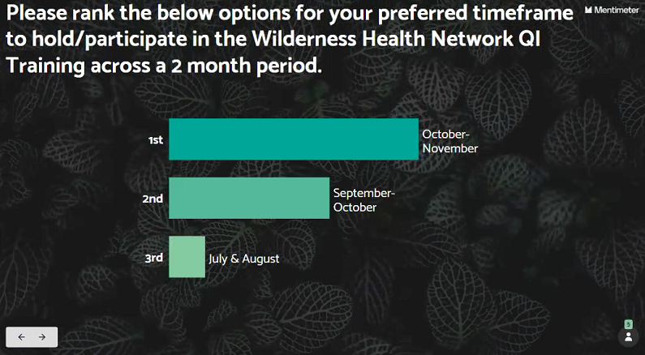  Next steps will be presenting proposal to board.
Wrap-up | Next meeting: July 12 from 7-8AM  May seek feedback from committee to see if time should change for meetings.  More info will be shared for quality education training
Adjourn | Adjourned meeting at 7:44 AM.

Present:

BigFork: ☒ Laura Vaneps
Community Memorial: ☒Marilyn Denno ☒Abby Witeli
Cook: ☐Nichole Chiabotti
Ely: ☒ Colin Yahnke ☐ Dr. Brock Urie
Fairview Range: ☐Heidi Lahti ☒ Angie Olson ☐Kasey Kapella ☐Stacy Wesley
Grand Itasca ☐Michelle Ingle
Lake View: ☒Beth Egan
North Shore: ☒Kimber Wraalstad
St Luke’s: ☐ Courtney Murphy-Bakken ☐ Dusty Moreland ☒ Dr. Anne Whitworth ☐ Leah Berg ☒ Lucia Tchida
Community Members: ☐Kim Dauner ☒Robert Prose
Wilderness: ☒Cassandra Beardsley ☒Michelle Hargrave ☒EJ Howarth ☒Katie Peck ☒ Dr. Gretchen Karstens ☐ Zomi Bloom ☐Alexis Sininger

Guests: _ _______________________ Minutes written by: EJ Howarth

WH Team f/up with Individual Members:
Michelle to send series invite to Abby.
Send out Mayo events that are offered.

