CC Preventative Scripts/Workflows: Anxiety, Asthma, CHF, COPD, Depression, Diabetes, Hypertension
Prior to calling patient, check their problem list, med list, when last visit was and when last AWV was.
These conversations will be documented as care coordination or nurse notes. Send all notes to the Provider’s workload for review by provider.
Any “positive” or concerning results notify the provider with URGENT message to workload and schedule a virtual visit for the patient.
Anyone with yes answers to any questions should have a virtual visit made.
If patient states they are experiencing chest pain, shortness of breath or any immediate safety concerns recommend patient to hang up and call 9-1-1 or assist them in doing that.

Anxiety (Administer GAD-7 screening tool on the phone. )
- Are you currently being treated or have you been treated in the past for anxiety-yes or no.
- Administer GAD-7 and record results in chart
  - If GAD-7 positive: the results of your GAD-7 suggest that you may be experiencing anxiety, do you agree with that: yes, no or maybe.
  - If GAD-7 negative: these results suggest that you are doing a great job of coping with anxiety. Keep up the great work!
- How do you find relief from your anxiety symptoms (More of a guiding question: what brings you relief? (alternative medicine, meditation, counseling, social interactions, exercise).
Asthma: Administer the Asthma Control Test (score of 19 or less may mean the patient’s asthma is not well controlled):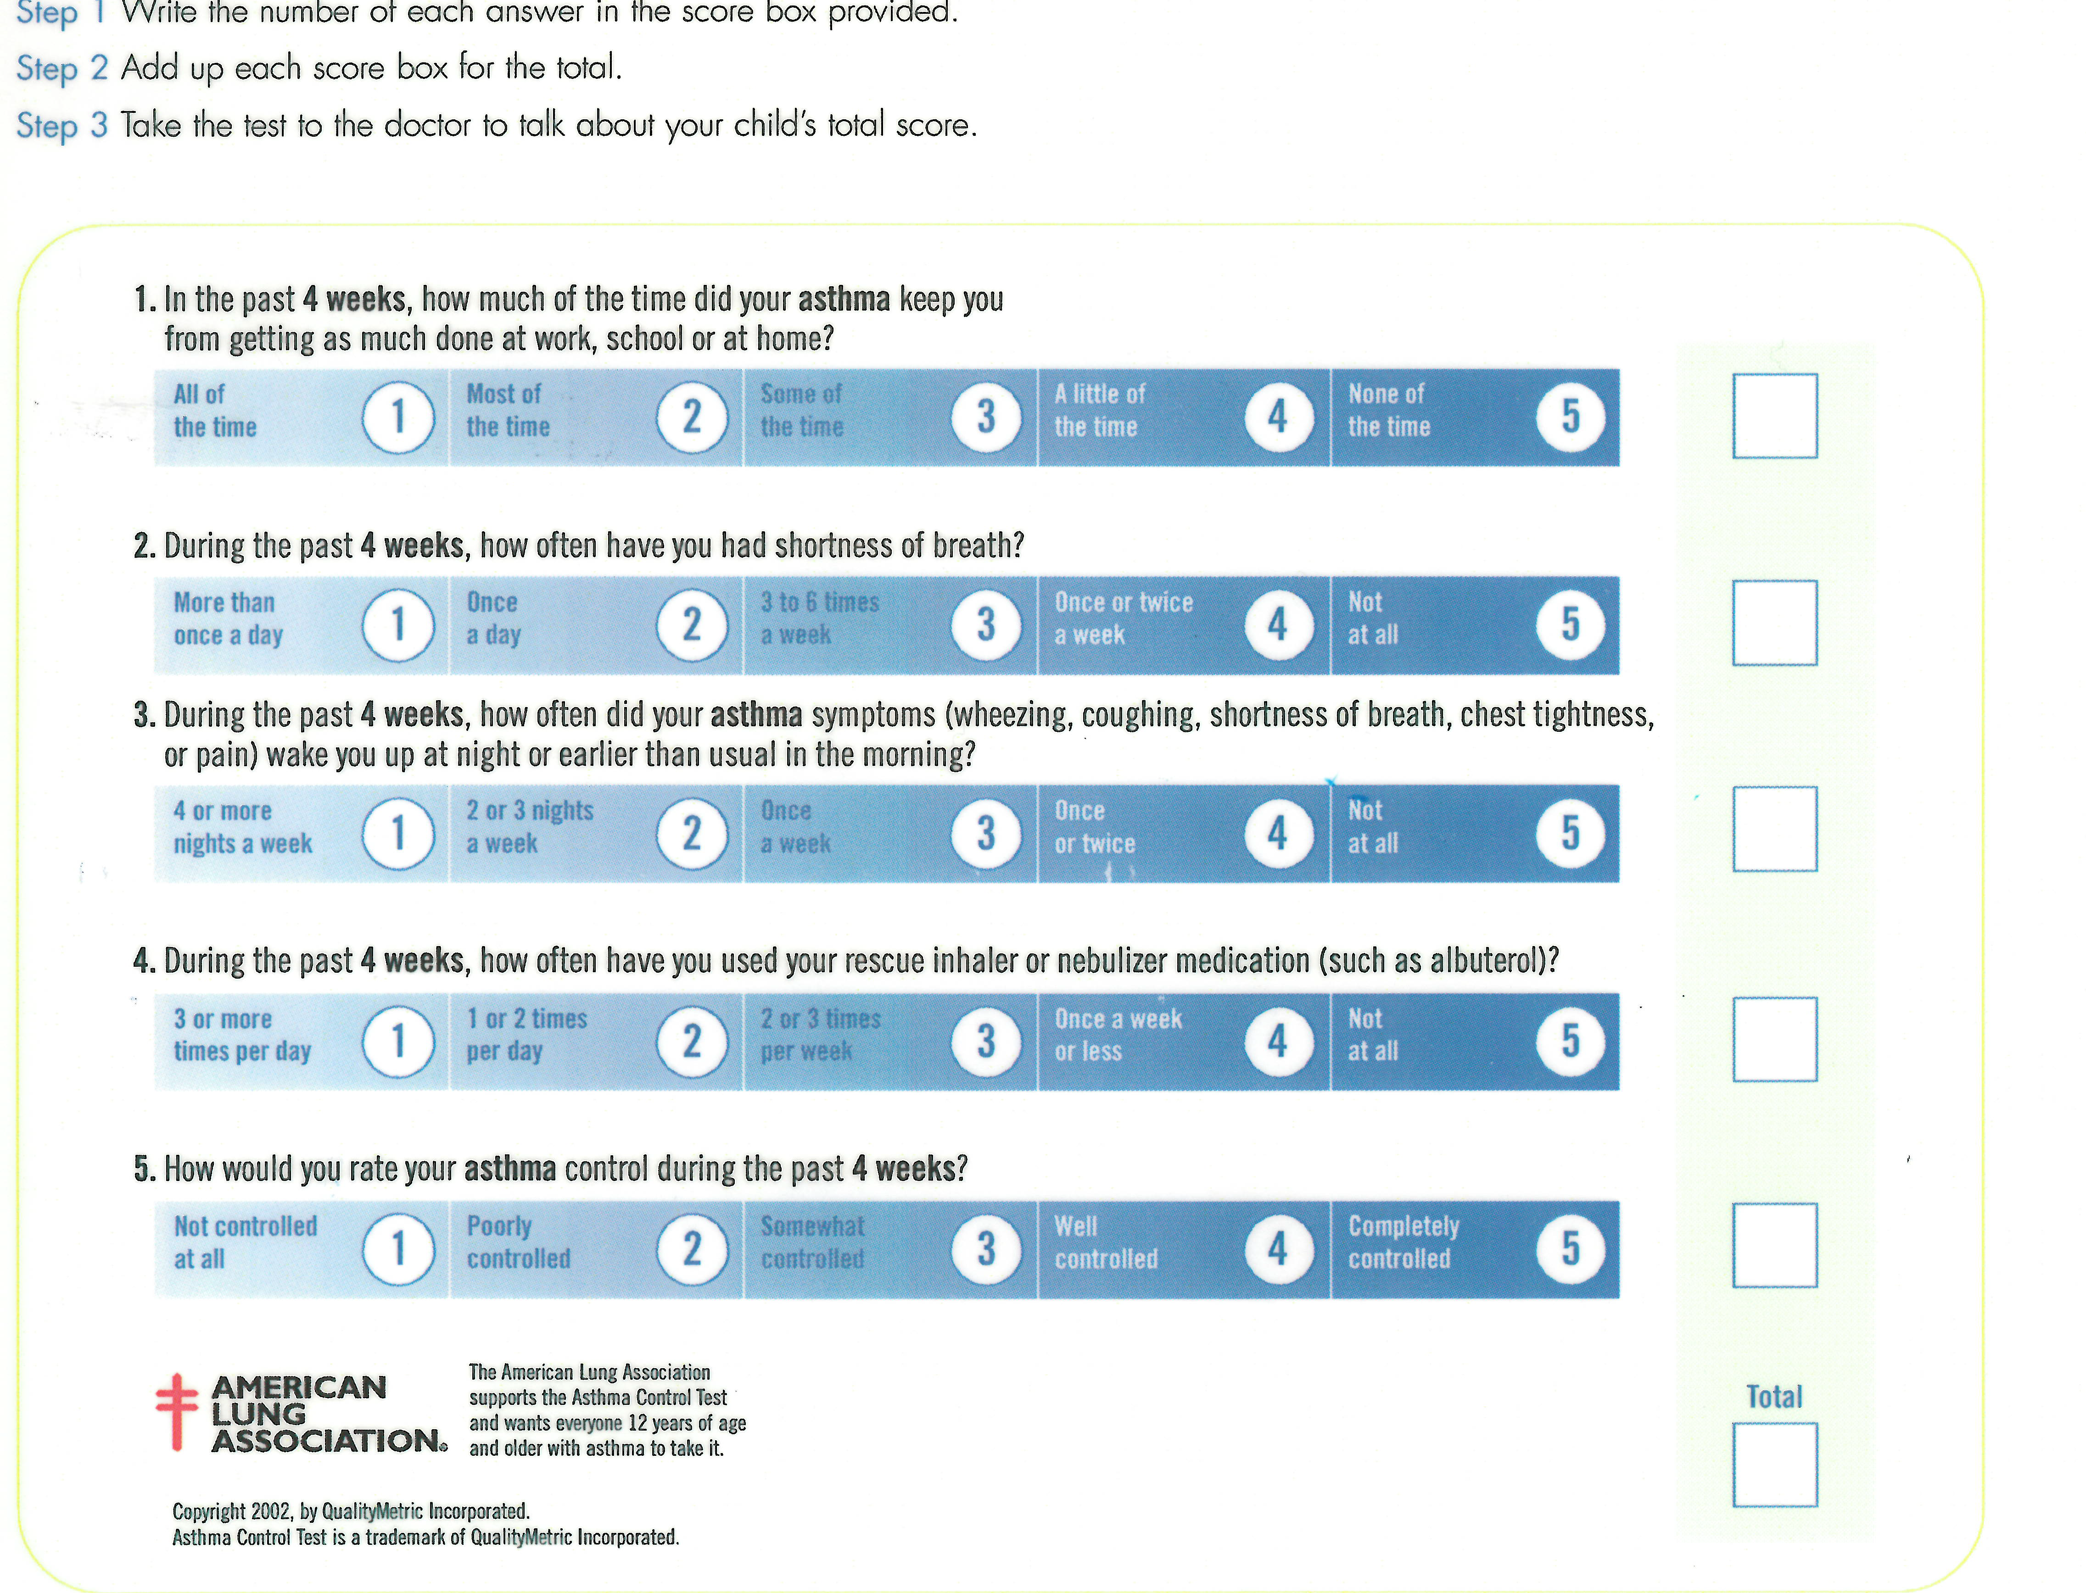
Additional Questions, Yes or No:
- Do you have:
  - Anxiety
  - shortness of breath
  - wheezing
  - cough
  - increased sputum
  - fever
  - chest pain
- Are you taking an asthma controlling medication as prescribed?
- Are you using rescue (quick acting) medication more than usual?
- Are you taking steroids by mouth for asthma?
- Are you participating in daily activities as desired?
- Have you woken in the night due to asthma?
- If you have allergies are you using your antihistamines, nasal sprays, and avoidance to help manage them?
- If you have GERD (reflux) are you using medication to manage it, which medicines?
- If you have obstructive sleep apnea, are you treating this nightly?
- If you are using nebulizers at home or high flow oxygen this can lead to an increased risk for airborne spread of the virus. We recommend that when suspected or COVID+ patient lives with other high risk individual(s) use oxygen or nebulizer in closed room, with no one entering the room for 90 minutes after use. The room should be wiped down after use.
CHF
- Are you experiencing any of the following symptoms, yes or no:
- Wheezing, or noisy breathing
- Cough
- Increased sputum
- Fever
- Chest pain
- Dizziness or lightheadedness
- Heart rate: fast, slow, irregular, palpitations, regular or other?
- Confusion
- Memory impairment
- Anxiety
- Insomnia
- Are you following your lifestyle modifications as prescribed (ie. daily weight check, diet/slow sodium, fluid restrictions)?
- Are you experiencing any swelling in your feet, ankles, lower legs, thighs, stomach, hands or face?
- Are you experiencing any fatigue or weakness?
COPD
- Do you also have anxiety: Yes or No
- Are you having any chest pain: Yes or NO
- Are you having any of the following, Yes or No?
  - Cough
  - Fever
  - fatigue (y/n/sometimes)
  - increased sputum
  - night sweats
  - change in weight
  - wheezing
  - Are your COPD symptoms limiting your activity?
- Are you taking your COPD medications as you discussed with the doctor?
- Have you taken or are you taking your steroids by mouth for COPD?
- Are you experiencing breathlessness?
  - With exertion, (minimal exertion, moderate exertion)
  - Breathlessness at rest
  - No breathlessness,
- If you have allergies are you using your antihistamines, nasal sprays, and avoidance to help manage them?
- If you have GERD (reflux) are you using medication to manage it, which medicines?
- If you have obstructive sleep apnea, are you treating this nightly?
- If you are using nebulizers at home or high flow oxygen this can lead to an increased risk for airborne spread of the virus. We recommend that when suspected or COVID+ patient lives with other high risk individual(s) use oxygen or nebulizer in closed room, with no one entering the room for 90 minutes after use. The room should be wiped down after use.

Depression (Can deliver the PHQ9 on the phone)
- Are you currently being treated or have been treated in the past for depression-yes or no
- After administering PHQ-9 and positive score: Based the results of the PHQ-9 screening it looks like you may be experiencing depression, does that sound right to you? OR If negative score: Based on these results, it looks like you are doing a great job managing your depression!
- What helps you find relief from your depression symptoms? Exercise, doing virtual chats with friends and family, preparing meals, meditation, supplements, alternative therapies
- Overall are your depression symptoms: improving, stable, worsening or resolved?

Diabetes
- Do you have any of the following symptoms: yes/no/sometimes
- Fatigue
- Neuropathy (numbness/tingling in feet, legs, hands)
- Visual Change
- Slow healing wounds
- Are your symptoms: improving, stable, worsening or resolved?
- Do you have any of the following hyperglycemic symptoms: yes, no, sometimes?
Trouble concentrating
Increased thirst
Headaches
Increased frequency of voiding
Increased appetite
- Do you have any of the following hypoglycemic symptoms: yes, no, sometimes?
- Confusion
- Dizziness/lightheadedness
- Headaches
- Hunger
- Mood Changes
- Nervousness/Anxiety
- Sleepiness
- Speech difficulty
- Sweats
- Feeling shaky
- Are you taking your medications as you and the doctor discussed? Do you have any questions about your medicines or need refills?
- Monitoring Regimen
- What is the # of times you check your blood sugar at home?
- Blood glucose ranges: what were your blood sugar readings in past 24 hours - low, high, overall range? What was your last blood sugar results and was it before or after you had eaten?
Hypertension
- Do you have any of the following: Yes or No:
- Anxiety
- Blurred vision
- Chest pain
- Cough
- Numbness and tingling in hands or feet
- Weakness
- Dizziness/lightheadedness,
- Fatigue
- Headache
- Orthopnea
- Palpitations
- Fluid retention (feet, ankles, legs, thighs, abdomen, hands, face)
- Shortness of breath
- Home blood pressure monitoring ability – what are your recent readings (get last 5-6 readings) – if MD reviews BPs can bill for this
- Overall are your hypertension symptoms: improving, stable, worsening or resolved?
C-19 Social Determinants of Health Screening:
- Have you or any family members you live with been unable to get the following:
- Food
- Clothing
- Utilities
- Child Care
- Medicine or any other healthcare (medical, dental, mental health, vision)
- Phone Service
- Transportation
- Other
- No, has all needs met
- Do you feel physically and emotionally safe where you currently live?
- Yes
- No: House unsafe,
  - Afraid of someone they live with?
  - Feel they live in an unsafe neighborhood?
  - Feel alone and isolated?
- Unsure
- Choose not to answer at this time
- Are you experiencing increased, disruptive stress around COVID-19?
-Yes: Can offer the Free Optum Public Crisis Line: 1-866-342-6892 or OptumEAP.org
-NO
4. What is housing situation today?
- I don’t have housing
-I don’t have housing and am staying with friends, family, or in a shelter
-I live on the street or in my car
5. How many people live you with currently?
6. How often to you talk to people that you care about and feel close to?
7. Are you afraid of your partner or caregiver?
8. How do you get to and from appointments, work, grocery/household shopping?
9. Have you or a family member filed for unemployment in past 6 months?

